BIND9 zone forward

1.

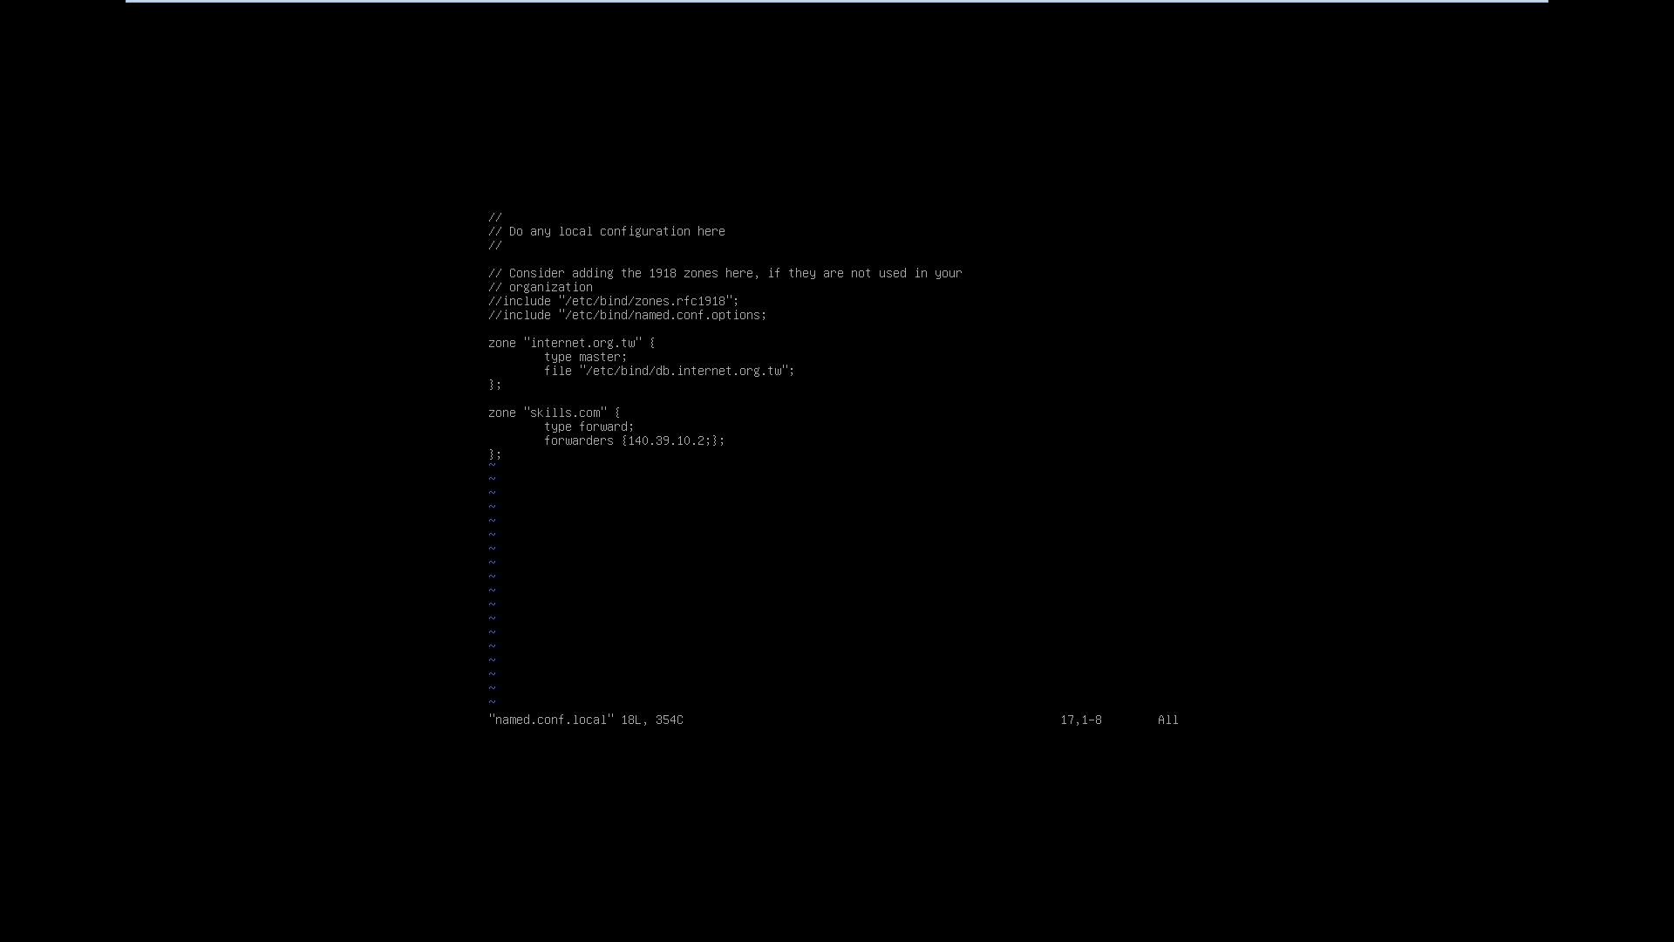

2.將dnssec-validation 由”auto”改成”no”

